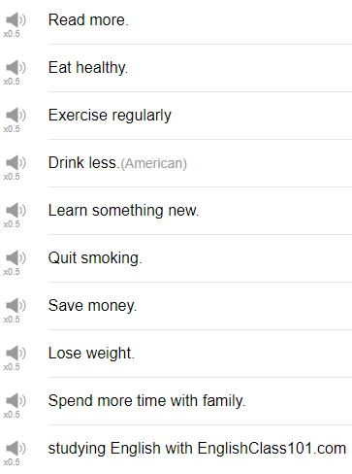

|  |
| --- |
| There's a comedian, a Vietnamese comedian named Dat Phan. There he is, Dat Phan! |
| Hi, everybody! Welcome back to Top Words! My name is Alisha, and today we're gonna be talking about 10 phrases that are related to New Year's resolution. So a new year's resolution, resolution is a special word for goal, the goals that we set for the new year, what we want to achieve in one year. So if you set some goals for yourself in January, maybe you can think about how you're progressing towards those goals now, as you watch this video. So let's start! |
| 1. Drink less |
| The first resolution is drink less. So maybe especially during the holiday season, maybe you drink a lot of wine, you drink a lot of beer, you go to a lot of parties with your friends, maybe one of your resolutions is to drink less. In a sentence, one of my new year's resolutions is to drink less. |
| 2. Eat healthy |
| Eat healthy is probably a resolution for many people, in connection with some related goals, and you gain a lot of weight, or maybe your body doesn't feel so good, so you decide I want to eat healthy this year. |
| 3. Exercise regularly |
| The next one is exercised regularly. Exercise regularly is a huge one for many people as a new year's resolution. Exercise regularly, again, especially following the holidays, eating a lot, drinking a lot, maybe going to a lot of parties, you gain some weight and you want to exercise. This is especially good in winter months if you live in a place where it's cold and dark in January and February, it can be a way to help you feel energetic and to keep up your energy levels throughout the winter months. So in a sentence, I really want to exercise regularly this year. |
| 4. Learn something new |
| So whether it's a language, like, English, maybe you decided to practice English this year, or it's a new hobby, like cooking, or dance, or swimming, or sports, whatever, photography, I don't know, you want to learn something new. If it were me, I would probably specifically say I'm going to learn (bla), I'm going to learn (hobby) this year, or maybe I would say I'm going to start taking lessons in this hobby this year, that would be a way to kind of motivate myself to do that. I've been thinking about taking calligraphy lessons, yeah, because my handwritten Kanji is very bad. |
| 5. Lose weight |
| Ok, the next one, this is probably the biggest, most popular, most common new year's resolution, it is lose weight. Lose weight, wanting to be a thinner, slimmer, trimmer, sexier version of yourself. Part of losing weight is eating healthy, exercising regularly, drinking less, and so on. So in a sentence, this year one of my resolutions is to lose weight. |
| 6. Quit smoking |
| This is a very clear goal that many people have, I think. Quit smoking many people would like to stop a bad habit or to stop a vice, so they decide to, they want to quit smoking in that year. My brother says he's going to quit smoking this year. It's one of his new year's resolutions. My brother doesn't smoke. |
| 7. Read more |
| The next resolution is to read more. I don't know, I suppose this could be different from person to person, it could mean reading the news more, it could mean reading more books, it could mean studying more, perhaps? But in general just getting new knowledge, more often. So in a sentence, this year one of my resolutions is to read more. |
| 8. Save money |
| Everybody probably tries to do this as much as possible, it can be difficult, but save money. So, for you know for your travels, for self-improvement, for whatever it is that you'd like to save money for. A common resolution is to save money. So this year, let's see, one of my resolutions is to save money so that I can travel this summer. |
| 9. Spend more time with family |
| The next resolution is to spend more time with family. It can be easy to move away from your family and not talk to them very much, maybe you lose touch over time, but one common resolution is to spend more time with family, so maybe this means calling your family more, meeting your family more, having a family reunion, there are a lot of different ways that you can find time. So in a sentence, this year I'm going to spend more time with my family, it's so important. |
| 10. Study English with EnglishClass101.com. The next resolution is to study English at EnglishClass101.com! Yes, so hopefully you're continuing your English Studies, I suppose that's why you're watching this video, and watching this channel. But a common resolution and is to study something more, so maybe for you studying English or studying another language is a resolution, is a goal for you, for the new year. Give yourself some time to review the material too. |
| So those are a few common new year's resolutions, I hope that you have some new year's resolutions and that you're working towards your new year's resolutions. If you have a resolution you would like to share, please leave it in a comment, and we can compare. Thanks very much for watching this time, and we will see you again soon, please be sure to subscribe if you have not already. Bye! |